TEAM4OARS

Feasibility Study

Version 1.0

Signature Block

COSC 4351 | Name Signature | Date
SE Team Leader
SE SQA

REPLACE Team Project with your TEAM?OXXS all uppercase one word

Feasibility study content hints:

This document contains the information about the feasibility of the Team Project TEAM?OXXS that your team is going to OOA, OOD, and OO Implement.

Find existing similar software products:

- get link,
- get screenshots;
- get technology,
- get interface,
- get cost,

Each team member, including the TL should do this research.
Show good ones versus bad ones, and how they solved some of the technical issues, such as live chat, security.

In the process start PROTOTYPING (find the Artist and Psychologist in your Team) your Team Project TEAM?OXXS and decide on the WEB SITE design (MASTER PAGE wireframe), each web page design, colors, pictures, links, etc. There should be actual work on your Team Project TEAM?OXXS while investigating similar systems.

TL Bertol Salgado

- Property Manager Point 2
https://www.diyres.com/
Trial for 14 Days
Uses ASP.net
Cost: $1 per unit monthly
Minimum $50.00 charge a month

Bad Ideas: Confusing when adding units to multiunit property. As well as it requires too much information. The user should not have to scroll down to continue filling out app. The data is all over the place

Good Ideas:
- Provide a tool to search units based on criteria as well as tenants (delinquent accounts, etc) and service requests per unit and tenant

- A dashboard to show any past due amounts and how many units are vacant view only by staff manager and owner and expand table to show more info on units

- Also alerts on when tenant is moving in and out. or new service requests were done, or payments posted

- Tenant should only see their information
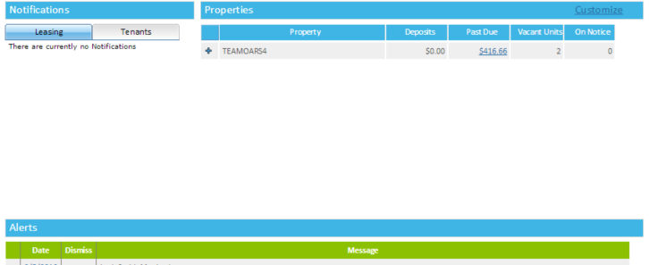
Dashboard

- Propertyware
https://app.propertyware.com/pw/logoff.do?ts=1454728648660
Trial 14 Days
Uses Javascript
Cost: Not found on website
Usage: Property Management Software

Bad Ideas:
- Menu Font is small and hard to read.
Good Ideas:

- Design of UI
- Well Organized
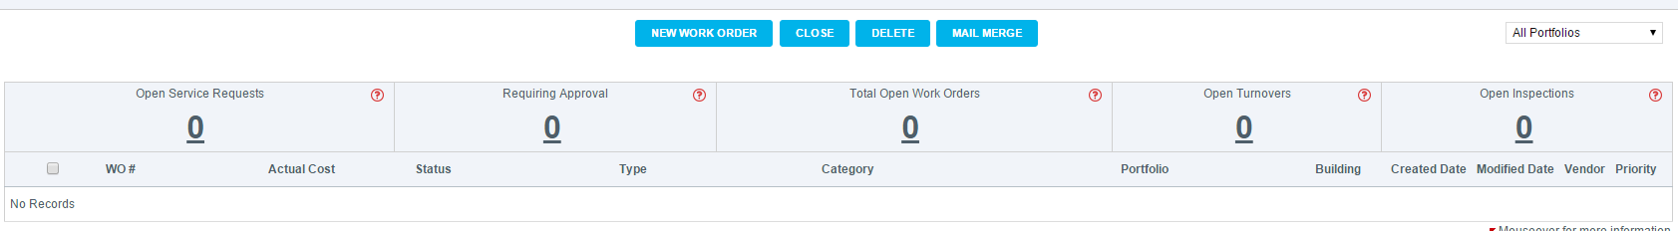
- Create Vendors to manage money out

- Work Orders,Leases, Grid

- Options menu for owners only

- Bulletin message to all tenants

Document Control

Change History

Table 1: TLs entries (assigned work and due dates) before releasing to the team
Revision | Name | Due Date | Description
1.1 | TM  Joshua Wilburn | 02/06/2016 | Research similar solutions to Project Requirements that are used in the Real World and send findings
1.1 | TM  Ali Khalid Elsaadi | 02/06/2016 | Research similar solutions to Project Requirements that are used in the Real World and send findings
1.1 | TM  Devin Bellomy | 02/06/2016 | Research similar solutions to Project Requirements that are used in the Real World and send findings
1.1 | DBA  Joseph Nguyen | 02/06/2016 | Research similar solutions to Project Requirements that are used in the Real World and send findings
1.1 | DBA  Stephen Carver | 02/06/2016 | Research similar solutions to Project Requirements that are used in the Real World and send findings
1.1 | SQA  Benjamin Wightman | 02/11/2016 | Research similar solutions to Project Requirements that are used in the Real World and send findings  Review Document after all findings have been submitted
1.1 | TL  Bertol Salgado | 02/06/2016 | Research similar solutions to Project Requirements that are used in the Real World and send findings. Go over and make a note

Table 2: Entries when work completed (SVN Commit Comment matches Description)
Revision | Name | Completed Date | Description
1.A | TM & Name | XX/XX/XXXX | I …..
1.B | TM & Name | XX/XX/XXXX | I …..
1.C | DBA & Name | XX/XX/XXXX | I …..
1.X | SQA & Name | XX/XX/XXXX | I reviewed Document

Table 3: TL entry for RED DELIVERABLES (SVN Commit Comment matches Description)
Revision | Name | Due Date | Description
2.0 | TL & Name | XX/XX/XXXX | I changed Version to 2.0

Document Storage
This file is stored in SVN at https://svn.cs.uh.edu/svn/cosc4351/team?/TEAM PROJECT DELIVERABLES/Feasibility Study.doc.

